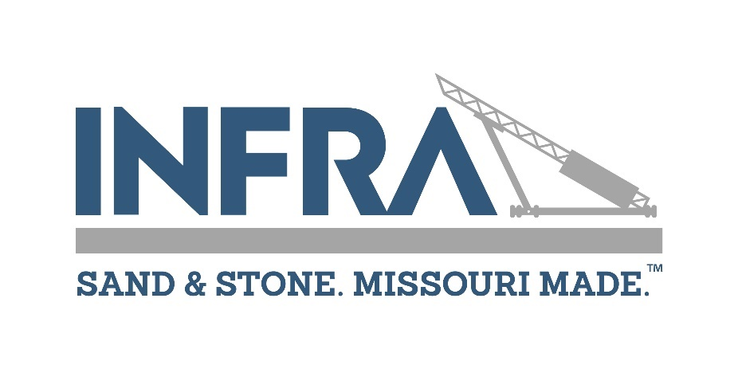

Infra
P.O. Box 1725, Jefferson City, Missouri 65102
Phone 573-635-0208 / Fax 573-634-8006 / www.molimestone.com

APPLICATION FOR AFFILIATE MEMBERSHIP

The undersigned hereby applies for membership in Infra and upon approval agrees to abide by the association's bylaws.

*** PLEASE PRINT OR TYPE ***

______________________________________________________________________________________
COMPANY NAME OF APPLICANT

______________________________________________________________________________________
ADDRESS CITY STATE ZIP

______________________________________________________________________________________
PHONE FAX WEB SITE

______________________________________________________________________________________
PRIMARY CONTACT NAME TITLE

_____________________________________________ ________________________________________
EMAIL ADDRESS MOBILE PHONE

______________________________________________________________________________________
SIGNED DATE

LIST PRODUCTS SERVICES _______________________________________________________

______________________________________________________________________________

______________________________________________________________________________

ELIGIBILITY REQUIREMENTS: Any individual, partnership or corporate business entity engaged in mining within the geographic limits of the State of Missouri; or a similar or related business activity, but not meeting the criteria of Producer Member. Producer Member is defined as any individual, partnership or corporation engaged in mining of stone and/or manufacturing crushed stone products. Affiliate Members may participate in committees, events and legislative efforts with the understanding that such participation will be consistent with MLPA’s Mission Statement.

AFFILIATE MEMBERSHIP DUES
Dues are $2,400. Make check payable to: Infra.

~ ~ ~ ~ ~ ~

Approved by Board of Directors: Date _________________Officer ________________________________

