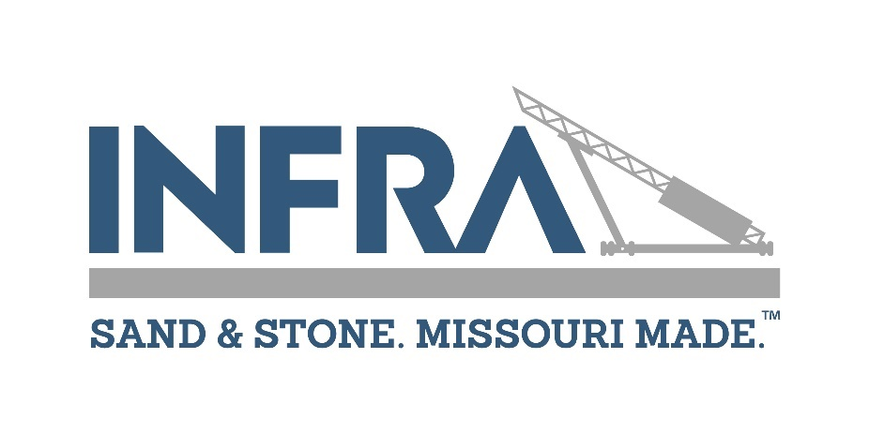

Infra
P.O. Box 1725, Jefferson City, Missouri 65102
Phone 573-635-0208 / Fax 573-634-8006 / www.molimestone.com

APPLICATION FOR ASSOCIATE MEMBERSHIP

The undersigned hereby applies for membership in Infra and upon approval agrees to abide by the association's bylaws.

*** PLEASE PRINT ***

______________________________________________________________________________________
COMPANY NAME OF APPLICANT

______________________________________________________________________________________
ADDRESS CITY STATE ZIP

______________________________________________________________________________________
PHONE FAX WEB SITE

______________________________________________________________________________________
PRIMARY CONTACT NAME TITLE

_____________________________________________ ________________________________________
EMAIL ADDRESS MOBILE PHONE

______________________________________________________________________________________
SIGNED DATE

LIST PRODUCTS OR SERVICES ____________________________________________________

______________________________________________________________________________

______________________________________________________________________________

ELIGIBILITY REQUIREMENTS

Any individual, firm or corporation supplying products or services to the stone industry is eligible to become an associate member.

ASSOCIATE MEMBERSHIP DUES
Associate Membership dues are $892.50 for 2025. Make checks payable to: Infra

~ ~ ~ ~ ~ ~

Approved by Board of Directors: Date _________________Officer ________________________________

